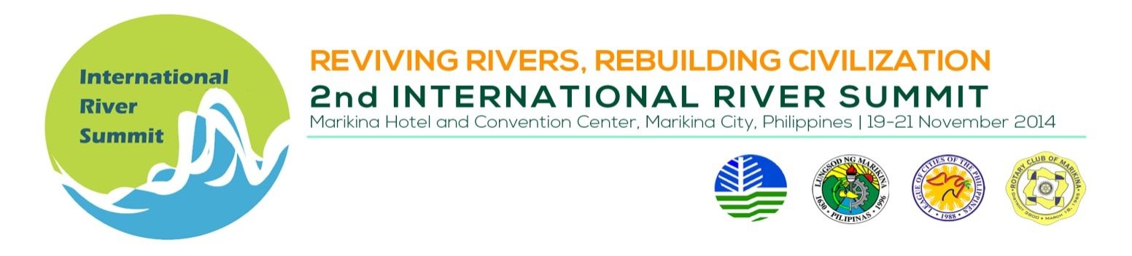
INDICATIVE PROGAMME

Thematic Session 1 : Water quality management

Venue : Plenary Hall Convention Center

Date/Time : November 19, 2014, 1:30 – 5:00 PM

Session Chair : Engr. Noel Hechanova, City Environment Officer, Iloilo City
Session Co-Chair : Dr. Evelyn Belleza, Professor, University of the Philippines Visayas

TIME | TOPIC | SPEAKER
 | Session Introduction | Engr. Noel Hechanova, City Environment Officer, Iloilo City
 | Novel approaches and technologies for restoration and protection of rivers, streams, and lakes | Subijoy Dutta, P.E,  Rivers of the World Foundation (presenter/ co-author) / William Roper, PhD, P.E.(co-author)
 | Water quality status, critical issues and action plan for Ganga River, India | Prof. Isaac Rajendra Kumar, Sam Higginbottom Institute of Agriculture, Technology and Sciences/ Executive Director, Institute of Rural Development and Research, Allahabad, India
 | Water quality management and the Philippine Clean Water Act | Engr. Vizminda Osorio, Supervising Environmental Management Specialist, DENR- Environment Management Bureau (DENR-EMB), Philippines
 | BREAK
 | Water Quality of the Lakes in Bangalore, India and their impact on the Kaveri (Cauvery) River | Subijoy Dutta, P.E (presenter) / Dr. Kusuma Cunningham, and William E. Danshin (co-authors)
 | Improved capacity for long-term water resources security in Iloilo, Philippines | Ms. Lisa Kircher Lumbao  Deputy Chief of Party  USAID Be Secure Project / AECOM International Development Philippines

